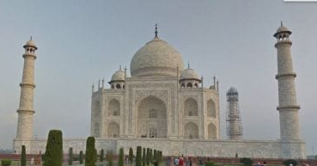
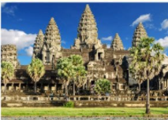
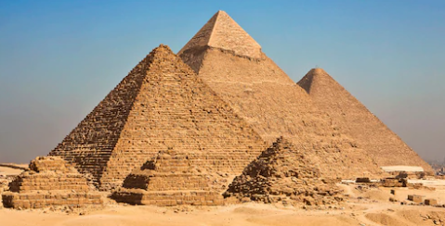

Brain Builder – Spring 2 2022

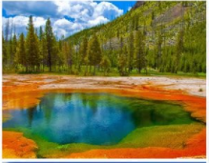
This is our DT and Topic Brain Builder. Your task is to investigate the other six of the seven ‘Wonders of the Ancient World’ (not the pyramids). You can either find out about one of the Ancient Seven wonders, or you can suggest a modern wonder of the world, and justify your choice. These websites might help you: https://kids.nationalgeographic.com/history/article/seven-wonders, https://www.weareteachers.com/wonders-of-the-world/

You could:
- Write about it and draw it in pictures to explain your choices
- Make a video of you explaining the wonder and some of its key features.
- Make a model of your ‘wonder’.
- Create a newspaper recount of the discovery of your ancient or modern wonder – include pictures and diagrams.
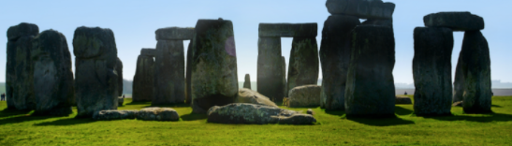
- Any other original and creative way that you can think of to describe and explain your choice of ‘wonder’.

Your Brain Builder is due on: Thursday 31st March 2022

